**ELECTRONIC TICKETING SYSTEM**

**TABLE OF CONTENTS**

1. **Introduction**
2. **Requirement**

* User Requirement
* Engineering Requirement

1. **Procedure**
2. **Diagrams**

* Flowcharts

1. **Conclusion**
2. **Names of group members**

**INTRODUCTION**

In most places, there has always been a problem of various queues as well as other issues when it comes to manually paying for one’s fare in a vehicle when travelling from one place to another. As software engineers, the development of an electronic based system is an idea we believe will help reduce such stressful situations in the transport department

**REQUIREMENTS**

**Engineering requirements**

A database that consists of the various details

1. Details of a passenger when he or she subscribes to take a particular vehicle.
2. The various destinations available to the passengers
3. The various buses available at each time period
4. The various times the buses will begin their journey to various destinations

A user interface that will help management to monitor and manage the system

An extensive knowledge of the C# programming language

Adoption of the waterfall software process which involves getting the entirety of the system’s logic before work could begin.

**User Requirements**

The system should be able to display the various locations or destinations passenger normally use

It calculates the cost of making the journey to a particular destination based on the kind of destination a customer selects

It provides the passenger a receipt or report that shows the bus ID, destination and the associated costs

It should provide a platform where payment modes can be established.

**FLOWCHART**

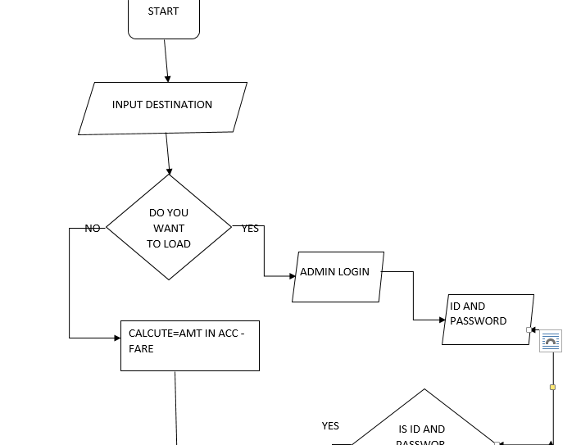

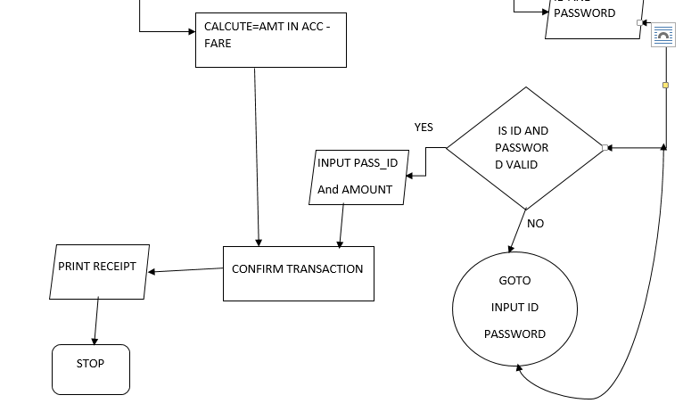

**PROCEDURE**

Using the C# platform on the Microsoft Visual Studio Development Environment, we first created a

Windows form and dropped some

Labels to indicate the various names of details going to be inputted

Buttons to either link to other related forms or to give us a particular output

Combo Box to help us generate reports in the form of receipts

Build a database to take care of the various details that will be inputted and generated when needed

Link the created database to the other parts of the project in the C# platform

Creation of a user friendly interface that will assist those managing the system to be able manipulate the system properly

THE USER INTERFACE

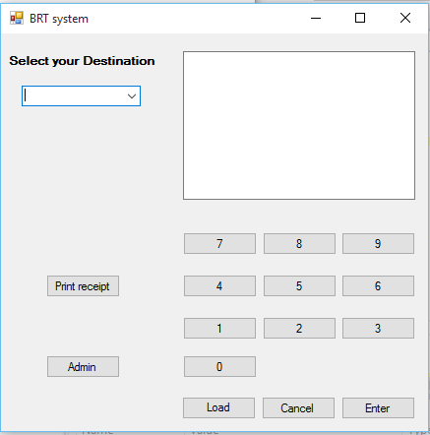

This is the initial user interface of the system which helps users to select which destination they will prefer to go to. There will be a notification on the phone of the various users registered on the system which will inform them of the various buses travelling that day as well as their times of departure. They then select where they are going. Once they are done selecting, the Administrator gets a notification and goes to his own interface to process their application.

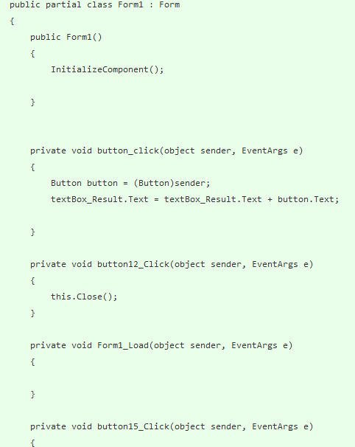

CODES FOR USER INTERFACE

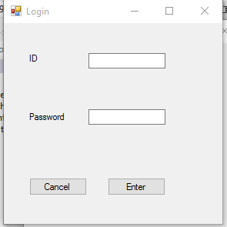

This is the form that contains the Administrator’s interface where he inputs his authentic identification number and password to authenticate him as an administration to further process the option the passenger or user has selected.

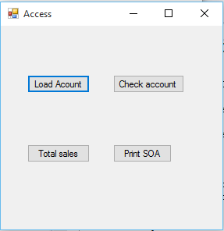

In this interface, the administrator gets a variety of options which includes Load account, Check account, Total sales, Print SOA

CODES FOR ADMINISTRATOR INTERFACE

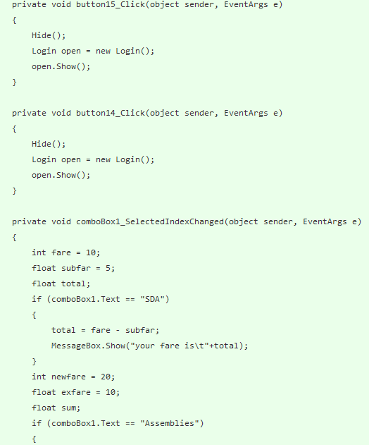

The Administrator processes the information and prints out a report for the user which shows their selected destination and the cost involved that will be debited from the passenger’s account

**CONCLUSION**

The Electronic Ticketing System will help customers to book their various buses in accordance with their preferred destination in advance and will help to minimize the long queues normally found at various bus stations. The system will go a long way to prevent the normal chaos and misunderstandings between drivers and passengers.

**NAMES OF GROUP MEMBERS**

**Adarkwa Emmanuel 215cs01003082**

**Isaac Ampofo 214CS01001514**

**Bansah Derrick 214CS01002408**

**Azure Micheal 215CS01002927**

**Cobblah G.D Hemade 214cs02002327**